AWS Lambda and Dynamo Exercise

Setting Up the DynamoDB Table

1. Go to the AWS Management Console and navigate to DynamoDB.

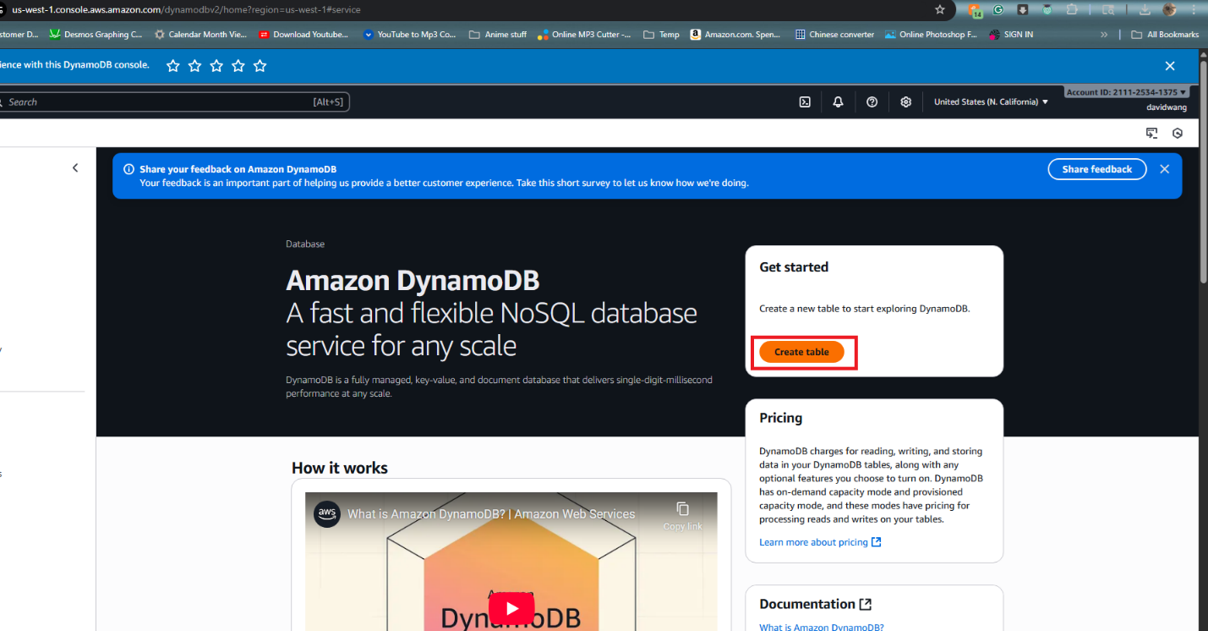

2. Create a new table:

o Table Name: StudentRecords

o Primary Key: student_id (String)

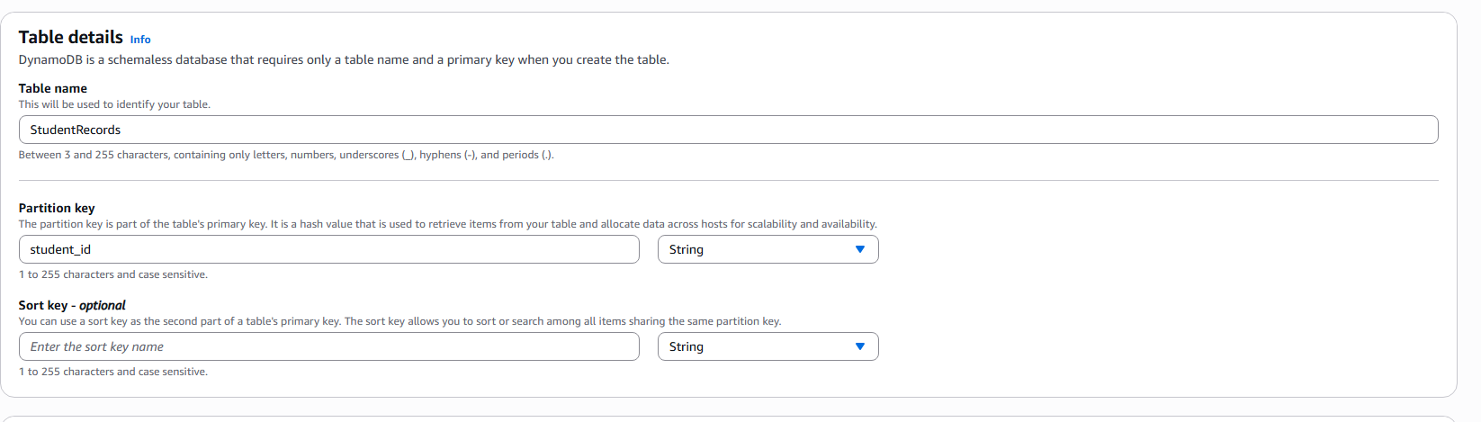

3. After the table is created, note down the table name.

Creating an AWS Lambda Function

1. Navigate to AWS Lambda in the AWS Management Console.

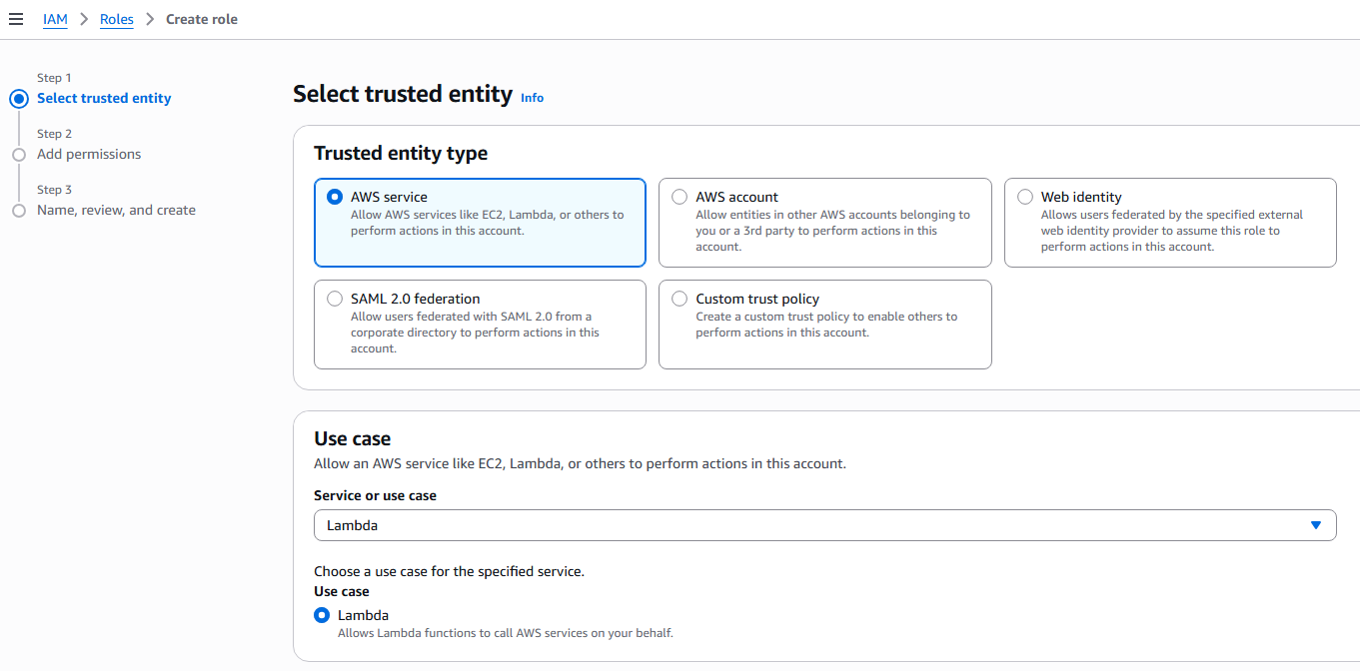

2. Create a new Lambda function:

o Function Name: StudentRecordHandler

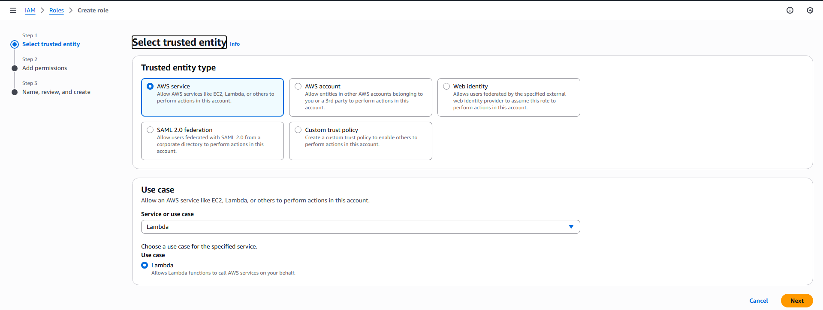

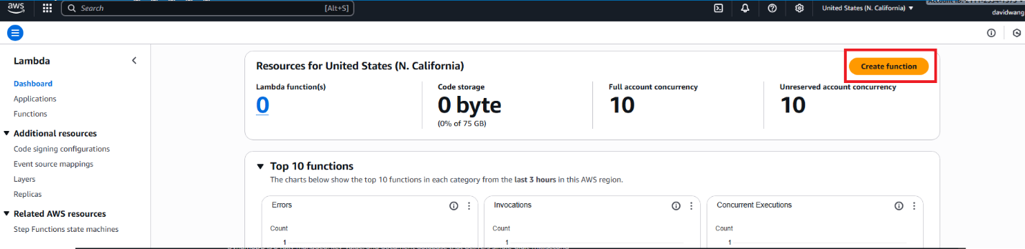

o Runtime: Choose Python 3.x or Node.js (depending on your preferred

language).

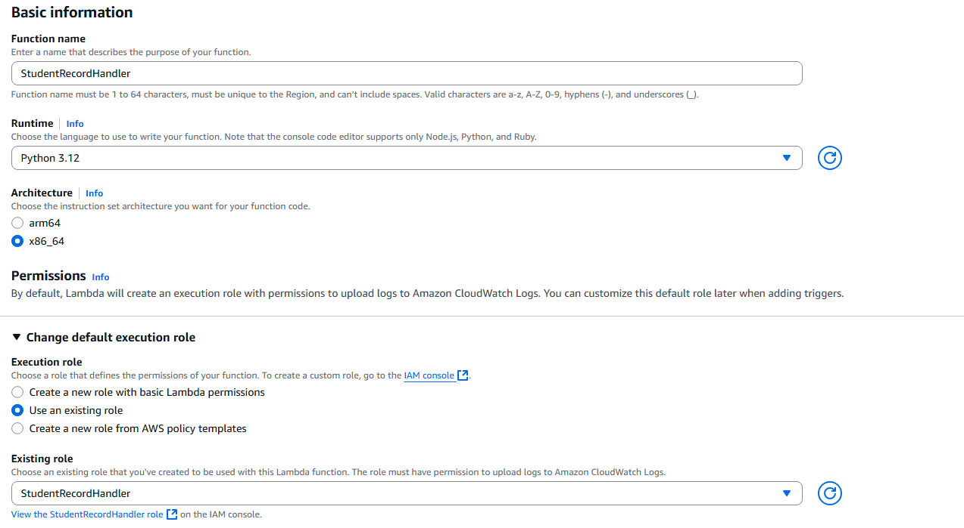

o Permissions: Attach the appropriate role to allow Lambda to

read/write to DynamoDB.

3. Inside your Lambda function, write code to handle basic CRUD operations

with DynamoDB. 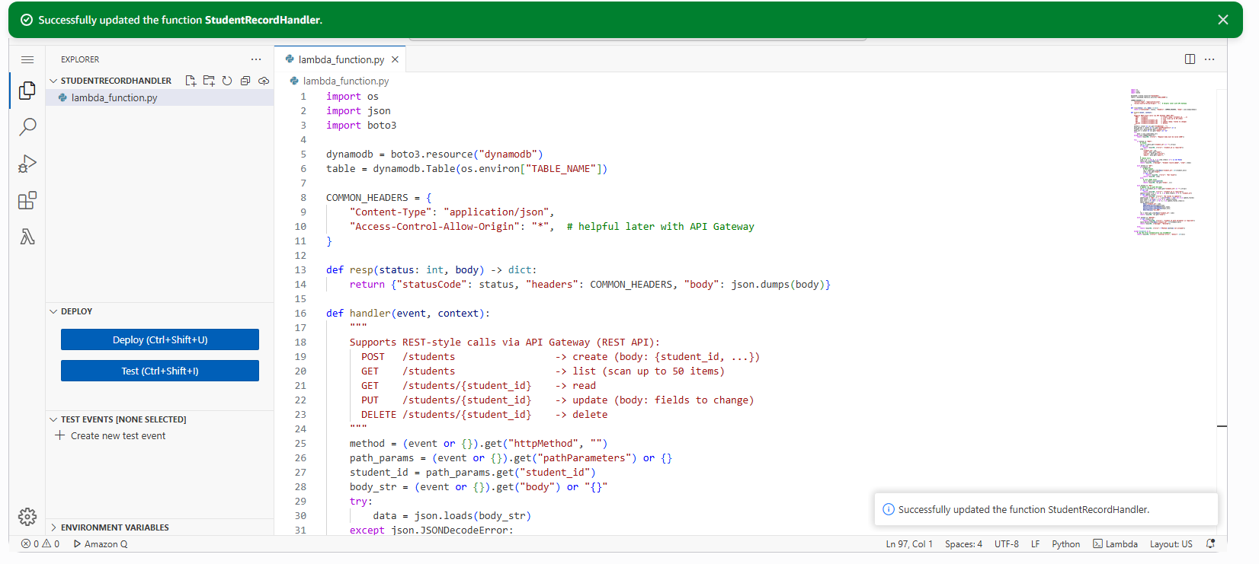

o Create: Insert a new student record into the DynamoDB table.

o Read: Fetch a student record by student_id.

o Update: Update a student's details.

o Delete: Remove a student record

Creating an API Gateway  
1. Go to API Gateway in the AWS Management Console.

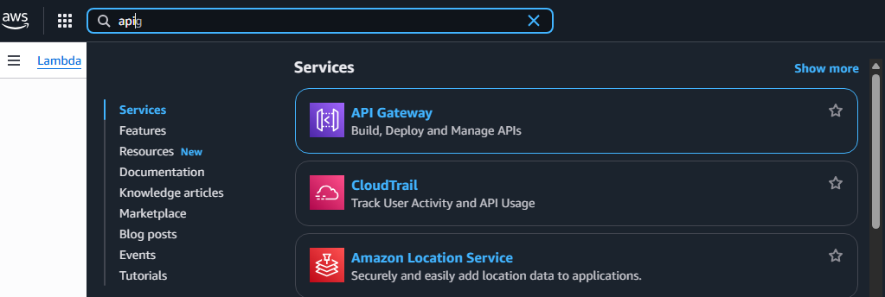

2. Create a new REST API:

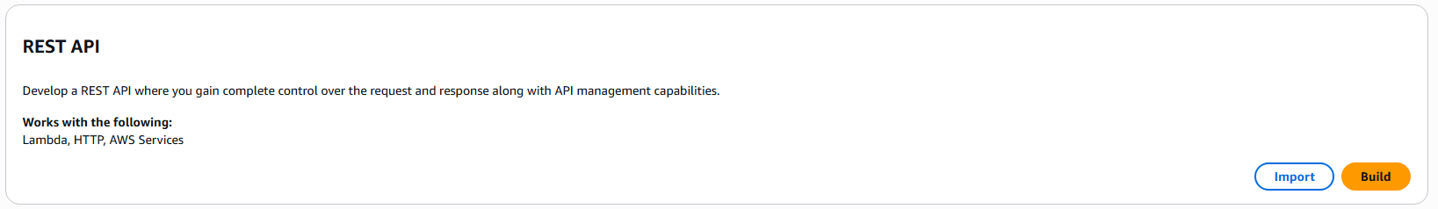  
o API Name: StudentAPI

3. Set up the following resources and methods:  
o POST /students: Trigger the Lambda function to add a new  
student.

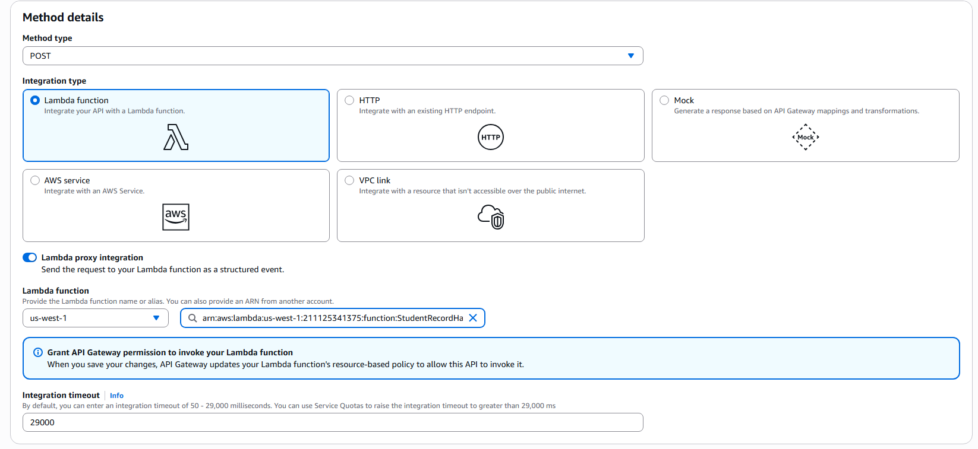

o GET /students: Trigger the Lambda function to retrieve student  
details by student_id.

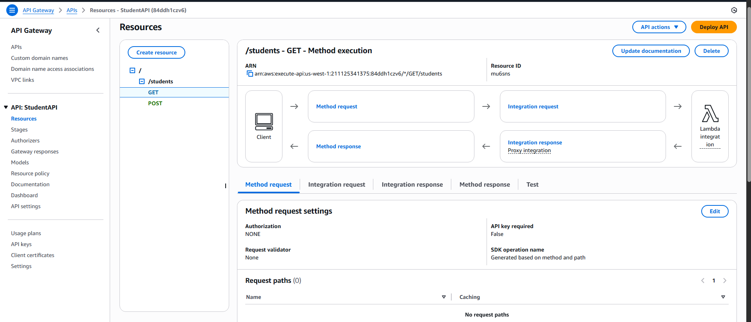

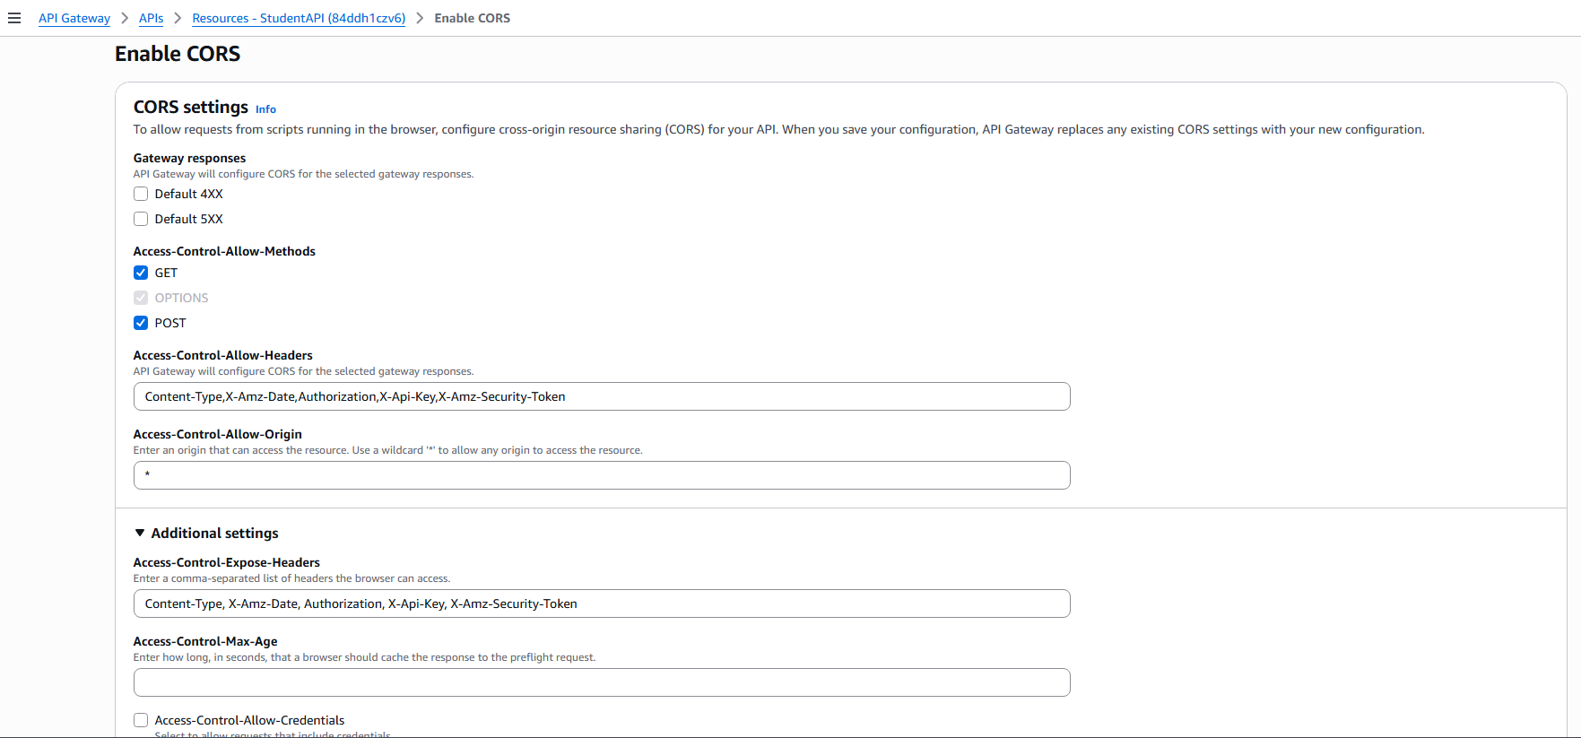  
4. Deploy the API and note down the Invoke URL.



Testing the Application  
1. Use Postman or curl to test the API by sending HTTP requests to the  
deployed API Gateway.  
2. Test the following operations:  
o Create: Add a new student record.



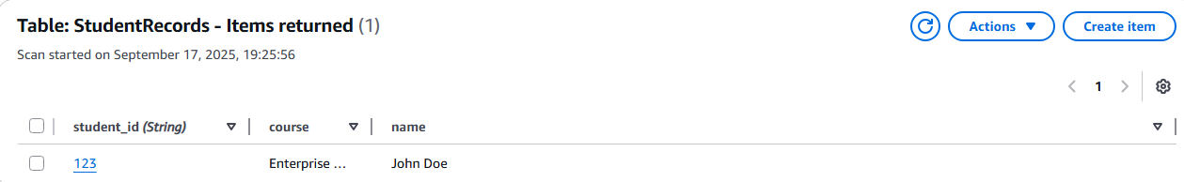  
o Read: Retrieve the student record using the student_id.



Reflection:

This exercise gives me a lot of insight on how API calls work. Which allows applications, websites, systems to communicate to each other regarding of what operating system they run on or where they are. Limitations are of course things like firewall or internet access but assuming you are not limited by either of those, APIs are how almost every function on the internet is running on. You can even use stuff like API keys to incorporate Agentic stuff like OpenAI directly into your code to have ChatGPT running or doing automation services. Ultimately APIs are the backbone of modern computing.